Servicenow Administration
Project Documentation
1. Introduction
• Project Title: Prevent User Deletion if Assigned to an Incident in ServiceNow
• Team Members:
• Team Leader: Yaramareddy Sai Chandrika
• Chagi Shivasindu – Role assignment & documentation
• Sorakayala Sumanth – User setup & validation testing
• Ediga Sunil – Incident configuration & optimization
• Busireddy Sharandeepreddy – GlideRecord logic & testing

2. Project Overview
Purpose
The purpose of this project is to prevent deletion of users who are assigned to active incidents in ServiceNow.
This ensures:
- Data integrity
- Incident ownership tracking
- Workflow continuity
- Audit compliance

Features
- Before Delete Business Rule on sys_user table
- Incident dependency validation using GlideRecord
- Automatic error message when deletion is blocked
- Successful deletion when no incident is assigned
- Optimized query using setLimit(1)

3. Architecture

Frontend
ServiceNow Web UI (Admin Form View)
- Admin initiates user deletion
- Displays error messages when validation fails

Backend
ServiceNow Server-side scripting:
- Before Delete Business Rule
- GlideRecord API for incident query
- setAbortAction(true) for blocking deletion
- gs.addErrorMessage() for notifications

Database
ServiceNow Cloud Tables:
- sys_user → User records
- incident → Incident assignments
The Business Rule reads from the incident table and controls delete operation on sys_user.

4. Setup Instructions

Prerequisites
- ServiceNow Developer Instance
- Admin role access
- Basic knowledge of ITSM module

Installation / Configuration Steps
- Navigate to System Definition → Business Rules
- Create a new Business Rule
- Set:
  - Table: sys_user
  - When: Before
  - Delete: Checked
- Add GlideRecord validation script
- Submit and test

5. Folder Structure (ServiceNow Equivalent)
Since ServiceNow is a SaaS platform, there is no local folder structure.
Logical structure:
- Business Rules
- Tables (sys_user, incident)
- Roles (itil, admin)
- UI Forms

6. Running the Application
No local server required.
Execution flow:
- Open sys_user record
- Click Delete
- Business Rule executes automatically
- System allows or blocks deletion

7. API / Script Logic Documentation

Business Rule Script
(function executeRule(current, previous) {
var incGr = new GlideRecord('incident');
incGr.addQuery('assigned_to', current.sys_id);
incGr.setLimit(1);
incGr.query();
if (incGr.next()) {
gs.addErrorMessage('This user cannot be deleted because they are assigned to one or more incidents.');
current.setAbortAction(true);
}
})(current, previous);

8. Authentication & Authorization
- Role-based access control (RBAC)
- Only users with admin role can delete users
- Business Rule runs server-side to prevent client bypass

9. User Interface
UI Components:
- User Form (sys_user)
- Delete button
- Error message display
(Insert screenshots of:)
- User form
- Assigned incident
- Error message

10. Testing
Testing Type:
- Functional testing
- Negative testing (assigned user deletion)
- Positive testing (unassigned user deletion)
- Performance testing
Result: 100% test cases passed

11. Screenshots or Demo
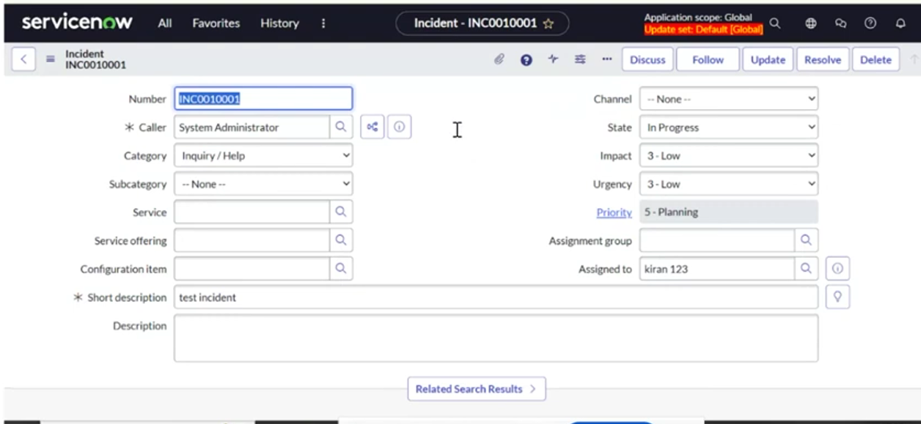
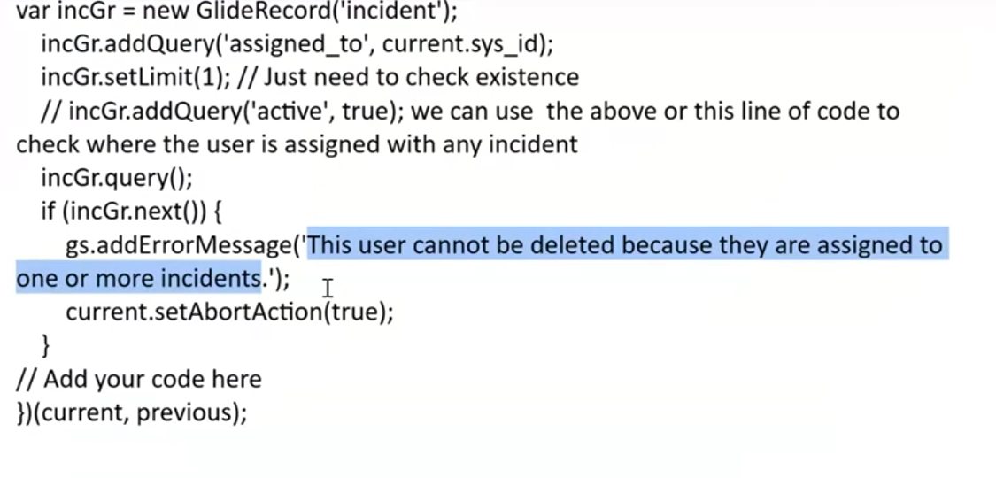
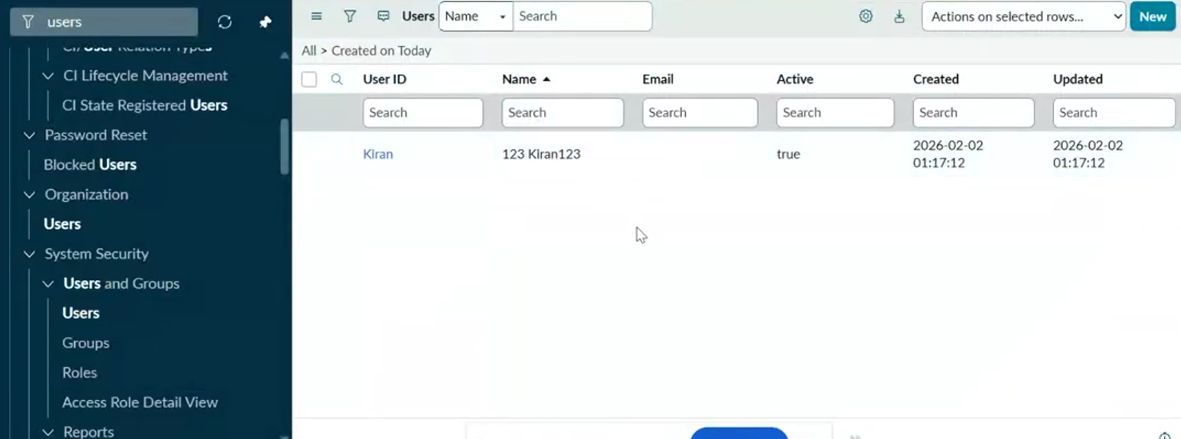

12. Known Issues
- Currently validates only Incident table
- Does not include Problem, Change, Task tables
- No admin override option

13. Future Enhancements
- Multi-table dependency validation
- Role-based override for super admin
- Dependency dashboard for users
- Scoped reusable ServiceNow application

